AI LAB 1
24k-0810
Q1: Write a program that:
- Takes user input for username, password, and age
- Stores the data in a dictionary
- Displays the dictionary in a formatted way
- Checks whether the user is allowed to create an account (age ≥ 13)
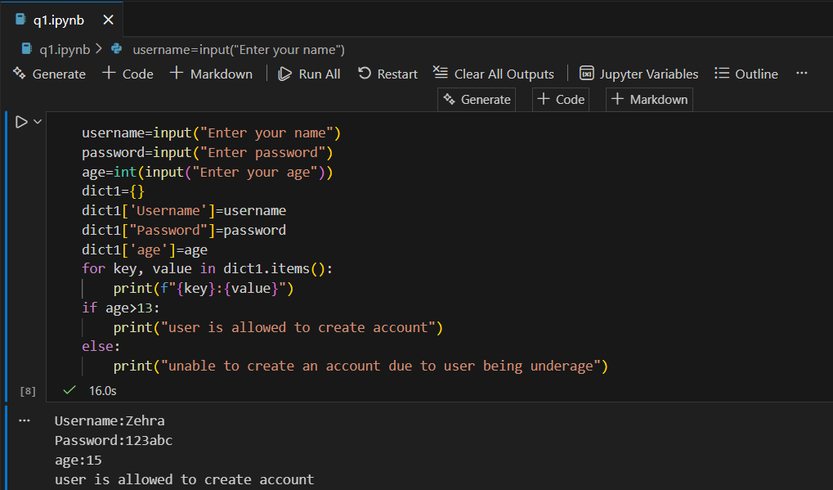
Q2: Write a program that: takes a string input from the user and prints:
- Second character of the string
- Second last character of the string
- Length of the string
- String converted to uppercase
- Number of words in the string
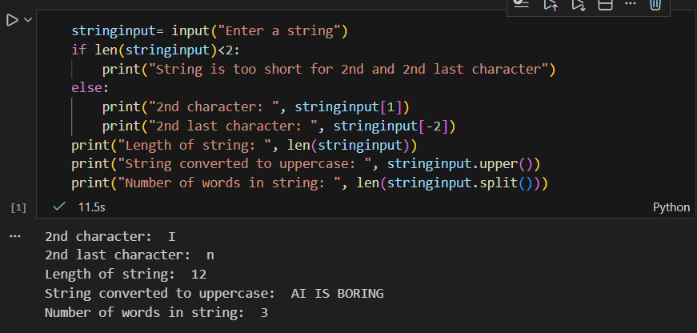
Q3: Create a program that takes n numbers from the user and stores them in a list. Uses a loop to:
- Display all numbers
- Count how many numbers are even
- Count how many numbers are odd
- Replace one element of the list at a user-specified index
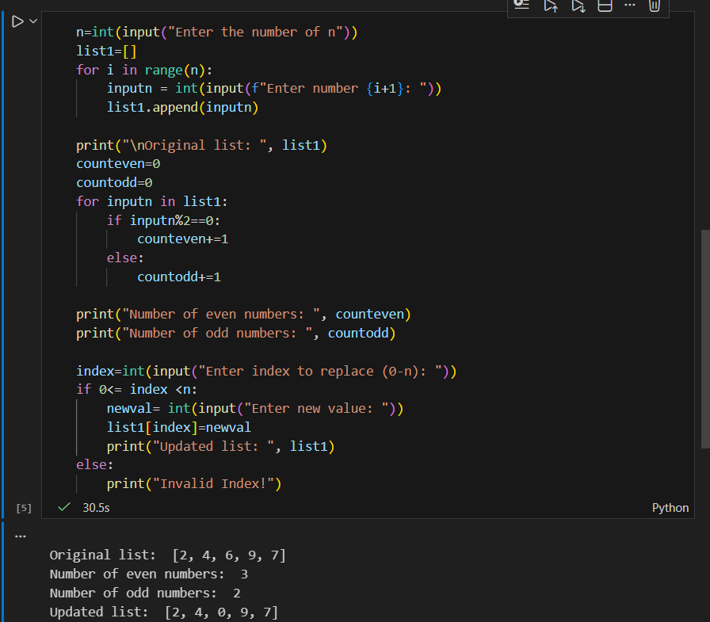
Q4: Create a function that takes basic salary as parameter and calculates:
- HRA = 10% of salary
- DA = 5% of salary
- Returns the total salary
- Call the function and display the result
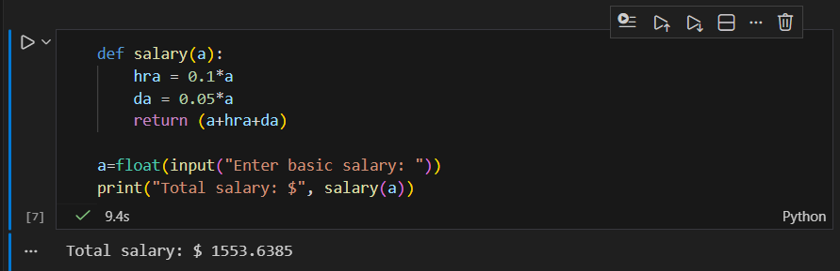
Q5: Create a function that accepts a string as input and returns a dictionary containing:
- Total characters
- Number of uppercase letters
- Number of lowercase letters
- Number of digits
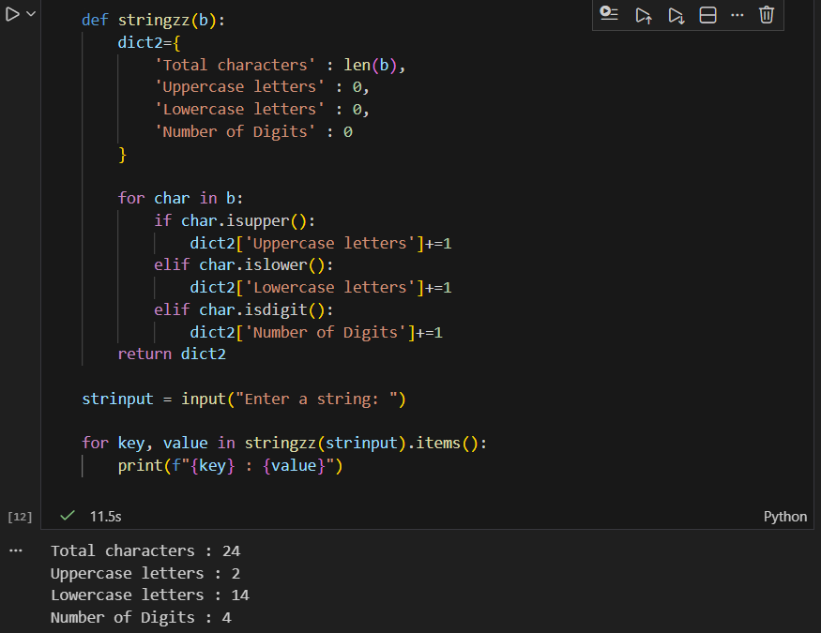
Q6: Write a Python program that takes a string from the user and finds the longest substring of consecutive identical characters and uses only loops and conditional statements. Prints: 1) The longest substring 2) Its length
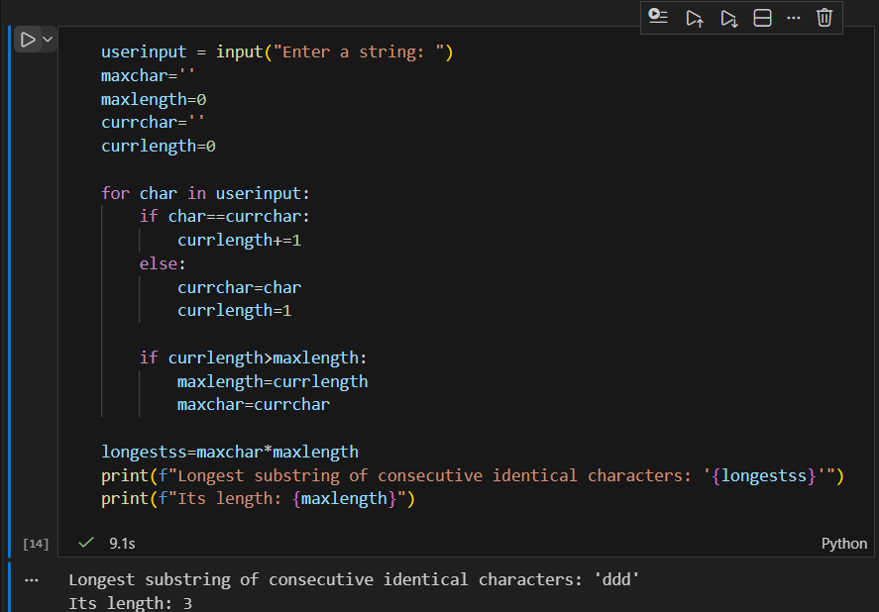
Q7: Write a Python function that:
- Takes a list of integers as input
- Finds numbers that appear more than once
- Returns each repeated number only once
- Do not use advanced libraries or built-in functions like set()
